[Unity3D]做个小Demo学习Input.touches

学不如做，下面用一个简单的Demo展示的Input.touches各项字段，有图有真相。

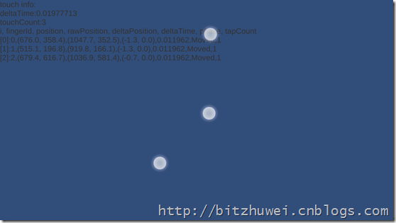

本项目已发布到Github，地址在（InputTouchsDemo）。

# 制作Demo

很简单，只需拉一个Text，然后添加一个脚本。

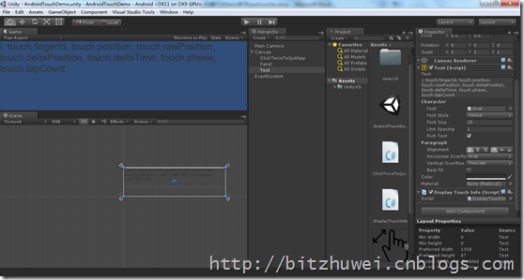

脚本如下。

|  |
| --- |
| using UnityEngine;  using System.Collections;  public class DisplayTouchInfo : MonoBehaviour {  private UnityEngine.UI.Text lblInfo;  // Use this for initialization  void Start () {  this.lblInfo = this.GetComponent<UnityEngine.UI.Text>();  }    // Update is called once per frame  void Update () {  var builder = new System.Text.StringBuilder();  builder.AppendLine("touch info:");  builder.AppendLine(string.Format("deltaTime:{0}", Time.deltaTime));  builder.AppendLine(string.Format("touchCount:{0}", Input.touchCount));  builder.AppendLine("i, fingerId, position, rawPosition, deltaPosition, deltaTime, phase, tapCount");  for (int i = 0; i < Input.touches.Length; i++)  {  var touch = Input.touches[i];  builder.AppendFormat("[{0}]:{1},{2},{3},{4},{5},{6},{7}", i, touch.fingerId, touch.position, touch.rawPosition, touch.deltaPosition, touch.deltaTime, touch.phase, touch.tapCount);  builder.AppendLine();  }  this.lblInfo.text = builder.ToString();  }  } |

# 使用

注意，必须发布到Android手机上才有效，PC貌似不搭理Input.touchs。